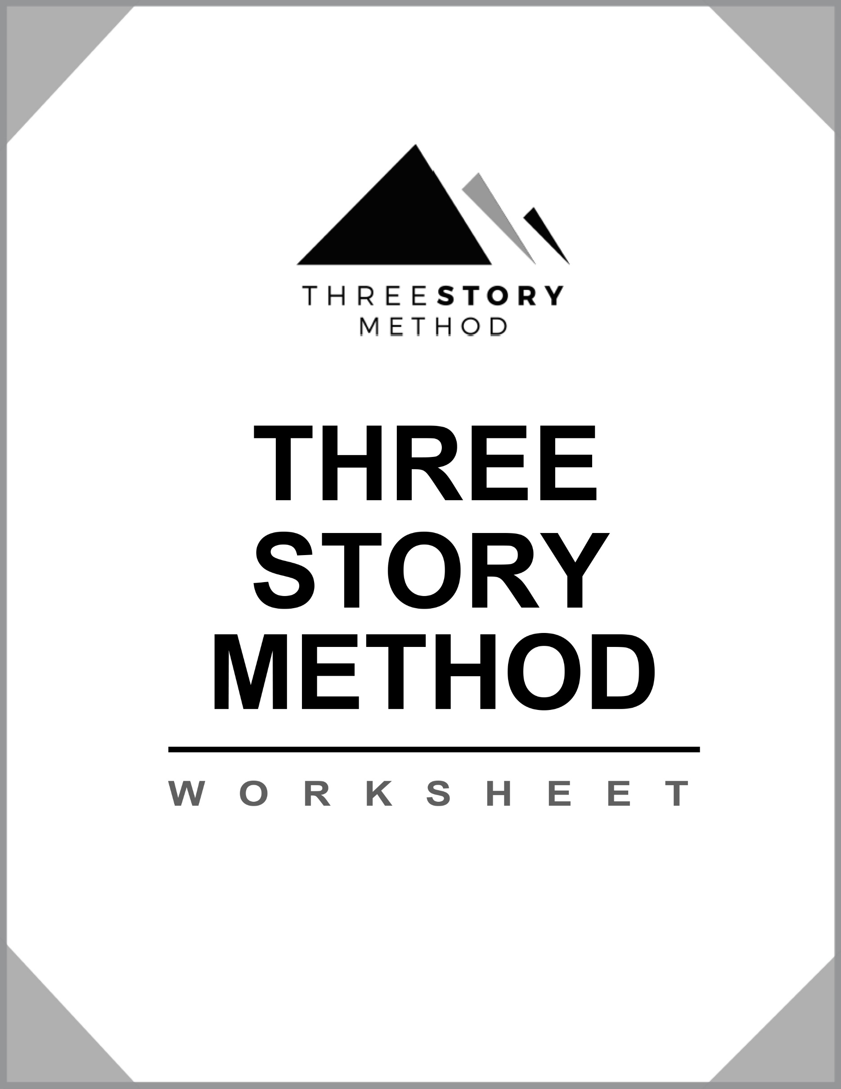
Author:
Project:
Date:

Plot

The Pixar Pitch
Once upon a time, [SOMETHING HAPPENS]:
Every day, [SOMETHING HAPPENS]:
One day, [SOMETHING UNUSUAL HAPPENS]:
Because of that, [SOMETHING INTENSE HAPPENS]:
Because of that, [SOMETHING EVEN MORE INTENSE HAPPENS]:
Until finally, [THE CONFLICT RESOLVES]:
Example: Once upon a time, there lived a boy named Luke. Every day, he helped his uncle on the farm and with the droids. One day he stumbles upon a mysterious message from Princess Leia. Because of that, he meets Obi-Wan who explains his Jedi heritage. Because of that, he is drafted into the Rebellion’s air fleet. Until finally, he lands the perfect shot to destroy the Death Star.
Your Pitch
[type it here using the format from above]

The Logline
When [CONFLICT OCCURS], [PROTAGONIST] must [OBJECTIVE], or else [STAKES].
Example: A teenage boy from a remote planet discovers a mysterious power that he must use to defeat a galactic, evil empire.
[type it here using the format from above]

Structure

For the entire story (beginning, middle, end)

Act 1 Conflict (Beginning)
Act 1 Conflict (Beginning) [WHAT SITUATION OR EVENT FORCED THE PROTAGONIST OUT OF HIS/HER STATUS QUO?]

Act 2 Choice (Middle)
Act 2 Choice (Middle) [WHAT IS THE BIGGEST, MOST DIFFICULT DECISION THE PROTAGONIST MUST FACE IN THE STORY?]

Act 3 Consequence (End)
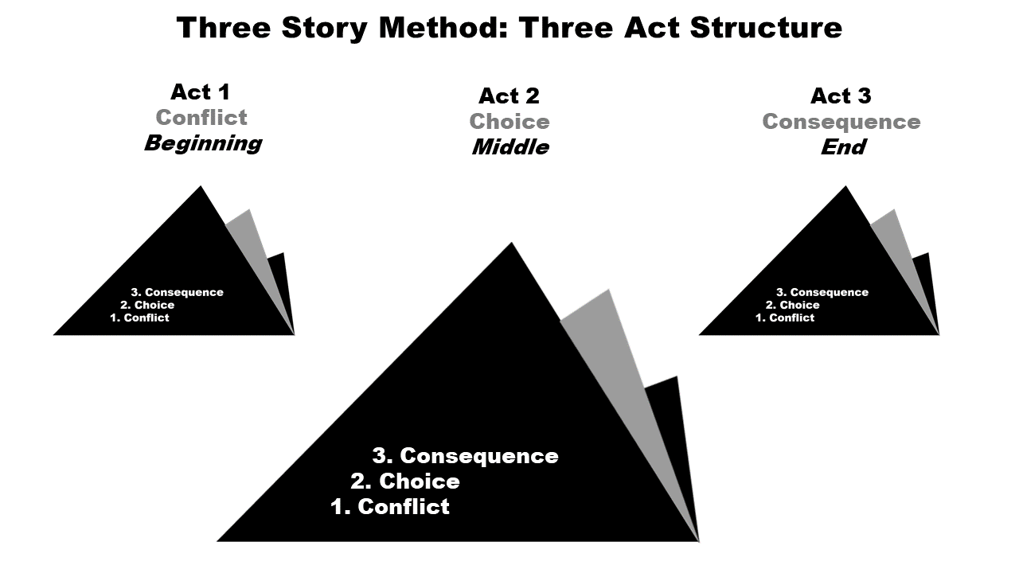
Act 3 Consequence (End) [WHAT IS THE RESULT OF THE CHOICE? WHAT IS THE NEW STATUS QUO?]
CONFLICT - Example: “Help me, Obi-Wan Kenobi, you’re my only hope.”
[type it here]

CHOICE - Example: Does Luke rely on his computer to make the shot, but knowing he’s going too fast, and a more experienced pilot has already missed, and Luke is their last chance or does Luke turn off the computer and use the Force which he hasn’t mastered and others look at cynically?
[type it here]

CONSEQUENCE - Example: Luke has transformed from whiny farm boy to intergalactic hero as he’s awarded a medal by Princess Leia.
[type it here]

12 Stages
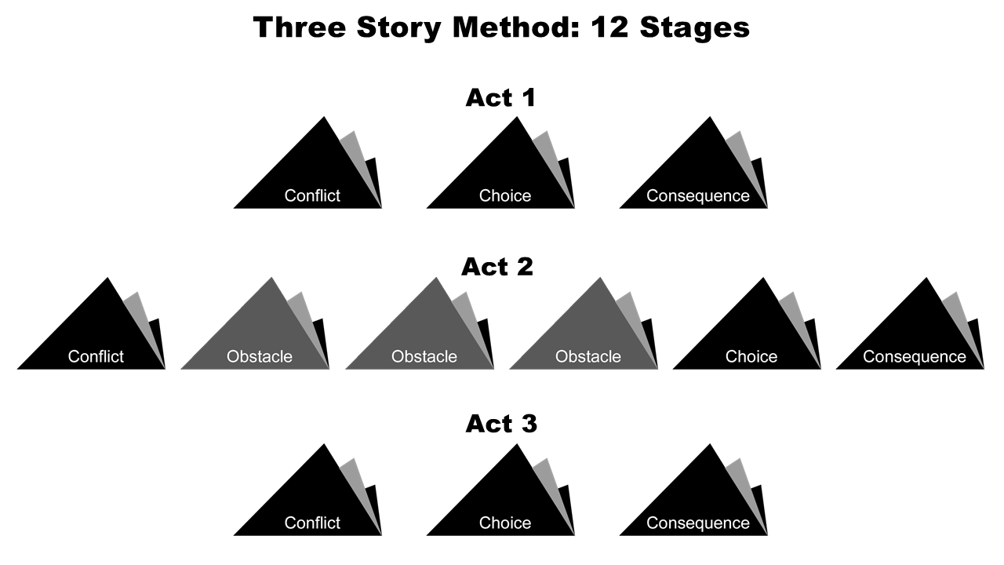
Act 1
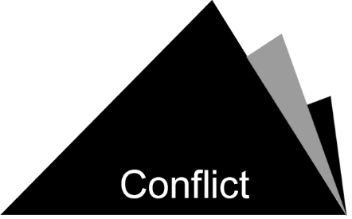 | [type it here]

[type it here]

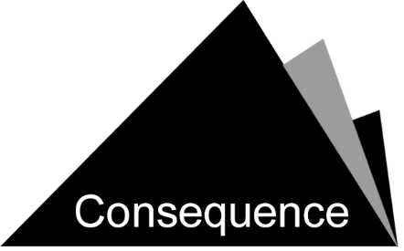 | [type it here]

Act 2
[type it here]

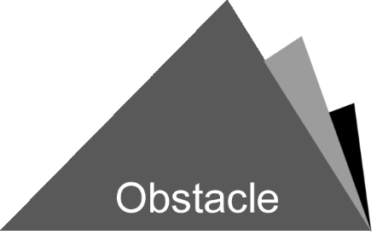 | [type it here]

[type it here]

[type it here]

[type it here]

[type it here]

Act 3
[type it here]

[type it here]

[type it here]

Genre
How will the protagonist grow or change over the course of the story? If there is no change, explain why.
[type it here]

What is the setting and when does the story take place?
[type it here]

Commercial genre (from Amazon.com).
[type it here]

Theme
What is the story really about? What are you trying to say about life, humanity, the world, etc. through the story?

Examples:
Just because you can’t see it doesn’t mean it doesn’t exist.
Women are and can be, as powerful as men.
Technology should be used with caution.
Ancient history and rituals matter.
[type it here]

Character
Example:
[paste picture of Mark Hamill as Luke Skywalker here]

Name: Luke Skywalker
Age: 19
Brief lists of physical traits: Blond hair, blue eyes, small build, older teenager
Occupation: Farmer
Marital Status: Single
Close Family and Friends: Uncle Owen, Aunt Beru, Obi-Wan, C3PO, R2-D2, Leia, Han, Chewbacca
Enemies: The Empire
Archetype: Hero (Main Protagonist)
Special Skills: The Force

Wants: Luke wants to leave Tatooine and his uncle’s farm to see the galaxy.
Needs: Luke needs a challenge that will help him grow beyond being a farm boy and into the hero who shares his gift with the greater world.
Intention: To be a famous fighter pilot.
Obstacle: His mundane life.
The lie he/she believes: His life will improve if he just gets accepted to the Star Fleet.

Protagonist:
[paste picture of actor from specific movie role here]

Name:
Age:
Brief lists of physical traits:
Occupation:
Marital Status:
Close Family and Friends:
Enemies
Archetype:
Special Skills:

Wants:
Needs:
Intention:
Obstacle:
The lie he/she believes:

Notes:

Antagonist:
[paste picture of actor from specific movie role here]

Name:
Age:
Brief lists of physical traits:
Occupation:
Marital Status:
Close Family and Friends:
Enemies
Archetype:
Special Skills:

Wants:
Needs:
Intention:
Obstacle:
The lie he/she believes:

Notes:

Other characters:
[list them here]

World

Robert McKee’s Setting Dimensions
Period | Location
Duration | Level of Conflict

Example:
Period: A long time ago. | Location: A galaxy far, far away.
Duration: A few months? | Level of Conflict: The battle between good and evil.

Period: [type it here] | Location: [type it here]
Duration: [type it here] | Level of Conflict: [type it here]

Rules of the world:
[list them here]

Planning

One story beat per scene or chapter. For each story beat consider:
Who?
What?
When?
Where?
Why?
How?
Example: Scene 12 // Day 78 // Luke POV // the Death Star // Night
On his way to the Millennium Falcon to escape the Death Star, Luke hears light sabers.

Should he intervene in the fight and save Ben but give up Leia, or does he leave Ben to a certain death to escape the Death Star with Leia to save the Rebellion?

Luke leaves with Han Solo, Princess Leia, and crew. Ben is killed by Darth Vader.

Outline

Scene #_____ // Day____ // POV____ // Location____ // Time____
Who?
What?
When?
Where?
Why?
How?
____________________________________________
____________________________________________
____________________________________________
____________________________________________
____________________________________________
____________________________________________
____________________________________________

____________________________________________
____________________________________________
____________________________________________
____________________________________________
____________________________________________
____________________________________________
____________________________________________

____________________________________________
____________________________________________
____________________________________________
____________________________________________
____________________________________________
____________________________________________
____________________________________________

*Copy/paste for all scenes.

