The “How To” Book Five-Day Challenge with J. Thorn

Prep Work:
Ask five people what they think you’re really good at that most people aren’t. Already know your superhero power? Put it in the first box and call it a day.

1.
2.
3.
4.
5.

Notes:

Day 1 Homework:
What is your Learning Avatar? Describe the qualities of your “perfect” teacher.
For the avatars, refer to the reference guide at the end of the worksheet.

My Learning Avatar:
The qualities of my perfect teacher:

Notes:

Day 2 Homework:
What is your Teaching Avatar? Craft the hook for your book using the “Five Ways” template.
For the avatars, refer to the reference guide at the end of the worksheet.

My Teaching Avatar:
My book’s hook:

Incorporate all five ways in whatever order you want:
- Reveal their potential (encourage dreams)
- Meet them where they are (justify failures)
- Make the complex simple (allay fears)
- Tap into their innate talent (confirm suspicions)
- Curate and focus their time (throw rocks at enemies)

Notes:

Day 3 Homework:
Look at the Energy Investment vs. Profit matrix and identify the quadrant that best suits your current circumstances.

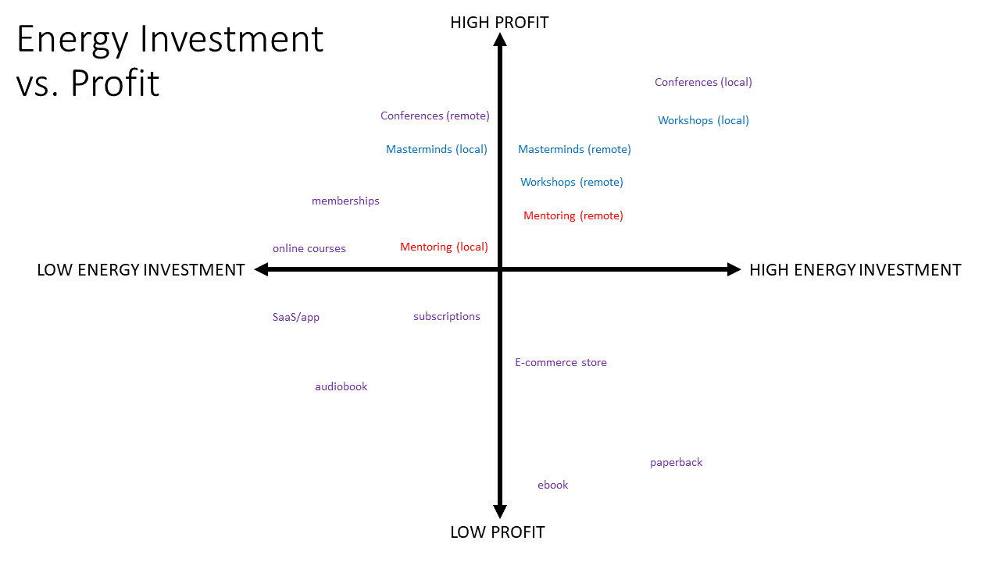

Using ✔- OR ✔ OR ✔+, place a symbol in every box of the teaching and learning modality matrix. Then pick the one that suits you best.

 | Online | In Person
1: One
1: Few
1: Many

Notes:

Day 4 Homework:
Step 1: Place a ✔+ in the box that matches your IDEAL teaching style with your IDEAL learning avatar (perfect student, not your personal learning style).
For the avatars, refer to the reference guide at the end of the worksheet.

 |  | Competitor | Cooperator | Wallflower | Cheerleader | Minimalist | Lone Wolf
 | Intellectual
 | Guru
 | Innovator
 | Big Thinker
 | Storyteller
 | Commander
 | Favorite
 | Connector
 | Coach
 | Manager
 | Friend
Step 2: Complete the lesson plan using this template.

Objective: What is the one thing you want students to learn from this lesson? Be as specific as possible.

Example: Movement is critical to your health and creativity.

Hook: How are you capturing your student’s attention? Consider using a joke, story, anecdote, illustration, or media. You can “call back” to this at the end of the lesson.

Example: When my children were little, the kids would fight for seats on the couch to watch their favorite shows. One time, I heard my 3-year old daughter shriek, “You can’t sit there!” My 5-year old son leapt off the cushion like his butt was on fire. “Why not?” he asked. “Because,” she said. “You almost sat in Dad’s butt groove.” I remember thinking, “Should I be worried that I have my own butt groove on the couch? Do I want my daughter protecting it? What does that say about how much time I spend on the couch? Is this the model I want to be for my kids?”

Procedure: What is the format of the lesson? How long will it be?

Example: Small group presentation via remote video (Zoom) with slides. 30 minute presentation, 15 minute question and answer.

Conflict: Explain why your student’s status quo must change (25% of allotted time).

Example: 7.5 minutes, slides 1-5.
- Stats on health risks of sedentary lifestyle
- Studies on benefits of daily exercise

Choice: Decision – Reveal the choice to keep status quo or change (50% of allotted time).

Example: 15 minutes, slides 6-15.
- Personal reflections on connection between movement and creativity
- Examples of writers who use walking or exercise as a creative tool
- Examples of exercise regimens for beginners

Consequence: Determination – Show your student how life is different now, for the better (25% of allotted time).

Example: 7.5 minutes, slides 16-20
- Question: Why kind of movement or exercise appeals to you most? Why?
- Group discussion: How can you get started? (shared experiences)

Review: Restate the objective and highlight the big takeaways. “Call back” to the Hook if appropriate.

Example: 15 minutes
- Proud to say I no longer have my own butt groove
- Restate: Movement, any movement, is critical to health and creativity
- Suggested action: For one week, track the time you spend seated
- Questions?

Feedback: Did you accomplish the objective? If yes, begin developing next chapter or section to teach. If no, revise and teach again.

Example: Ask students to answer a poll, use a follow-up survey, or ask individuals if they’ve tracked their time seated, and if that’s made them more aware of it.

Notes:

Day 5 Homework:
Brainstorm as many possible lessons/chapters as possible.

1. | 16.
2. | 17.
3. | 18.
4. | 19.
5. | 20.
6. | 21.
7. | 22.
8. | 23.
9. | 24.
10. | 25.
11. | 26.
12. | 27.
13. | 28.
14. | 29.
15. | 30.

Notes:
Extra Credit: Submit your first chapter draft to be analyzed by a certified Three Story Method Editor.

If you complete your first chapter draft by July 1, 2022, you’re eligible to have it analyzed for just $24.99. This exclusive service is only for challenge participants, and the offer expires on July 1. If you’d like to take advantage of this special offer, email J. (jthorn.writer@gmail.com) and he’ll connect you with a certified Three Story Method Editor.

Below is a customized, “First Chapter Nonfiction Rubric” designed exclusively for this challenge. It is the same rubric the Three Story Method Editors will be using to evaluate your first chapter.

Author:
Working Title:
Style [Expository, Descriptive, Narrative, Persuasive]:
Tone [Conversational, Humorous, Academic, Serious]:
Date:

Problem (“Have I clearly defined the problem?”)
Underdeveloped | Fair | Good | Excellent
The problem is vague, too broad, or too narrow. The reader does not identify the problem as theirs and therefore, they put the book down.  The audience is undefined. | The problem addresses a concern, but it doesn’t cause enough “pain” to force someone to change their behavior.  The audience is vague, too broad, or too narrow. | The problem addresses a concern, and the possible outcomes are severe enough that the reader must acknowledge the “pain” and its eventual consequences.  The audience is specific and identifiable with a “customer archetype” created. | The problem identifies a concern shared by many people who are clamoring for a solution because their “pain” is unbearable.  The audience is purposefully targeted, complete with a detailed “customer archetype” created from a large sample size.
Notes:

Solution (“Have I clearly defined the solution?”)
Underdeveloped | Fair | Good | Excellent
The solution is vague, too simple, or too complex. The reader cannot see the solution working for them and therefore, they put the book down. | The solution addresses the problem, but it is presented in a way that makes the action unrealistic or burdensome. | The solution addresses the problem, and the reader can visualize implementing a plan that will create the desired results. | The solution solves the problem with specific, actionable steps that can be completed in a reasonable amount of time.
Notes:

Premise and Hook (“Is my premise unique, engaging, and/or provocative?”)
Underdeveloped | Fair | Good | Excellent
There is no “hook” to draw the reader into the book and/or the premise is vague or unclear. | The “hook” is weak or only tangentially related to the premise. The premise is oversimplified or obvious. | The “hook” engages the reader’s interest and plants the seed for a unique payoff. | The “hook” is so strong that that reader cannot put the book down. The premise is unique, engaging, and provocative in a positive way, resulting in strong word-of-mouth recommendations.
Notes:

Conflict (from Three Story Method)
Underdeveloped | Fair | Good | Excellent
The protagonist (author or avatar) does not face an initial Conflict. The event pushing the character out of the status quo is missing. | The initial Conflict is present but lacks the intensity to make a reader care. The protagonist (author or avatar) can avoid or defuse the obstacle presented by the Conflict. | The initial Conflict propels the protagonist (author or avatar) into a situation that forces a Choice. The character cannot go back to the previous state and cannot do nothing. | The initial Conflict catches the protagonist (author or avatar) and reader by surprise. The event creates an unavoidable situation and should logically set the stage for a sequence of events leading to the Choice.
Notes:

Choice (from Three Story Method)
Underdeveloped | Fair | Good | Excellent
The protagonist (author or avatar) does not face a Choice. The character is completely passive or reactive, acting without agency. | The Choice is too easy for the protagonist (author or avatar). The stakes for all the consequences are not equally positive or negative. | The Choice posed to the protagonist (author or avatar) is difficult. The character struggles to determine the best path forward. | The Choice becomes incredibly difficult for the protagonist (author or avatar). The character cannot see a way out of the predicament, and neither can the reader, which should set up a surprising but inevitable Consequence.
Notes:

Consequence (from Three Story Method)
Underdeveloped | Fair | Good | Excellent
Because the protagonist (author or avatar) is passive or reactive, the Consequence is dull and one that the reader anticipated, creating an unsatisfying ending. | Because the Choice is too easy for the protagonist (author or avatar), the Consequence is obvious and easily predicted by the reader, but there is minor satisfaction when the reader correctly guesses the outcome. | When the protagonist (author or avatar) struggles to determine the best path forward, the Consequence is often unexpected, which delights the reader. | With an incredibly difficult Choice for the protagonist (author or avatar), the Consequence strikes the perfect balance of surprising but inevitable.
Notes:

Learning Avatars and Teaching Avatars – Quick Reference Resource

Learning Avatars

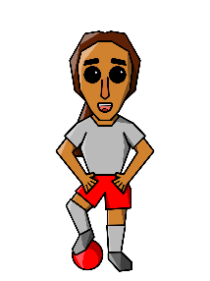 | “The Competitor”: Competes for rewards and accolades, thrives on public recognition.  - Positive Attributes: Driven to succeed, motivates peers.  - Negative Attributes: Self-serving, can hamper collaboration with peers.
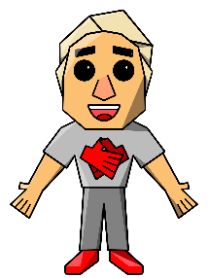 | “The Cooperator”: Learns by sharing ideas, cooperates with leader and peers.  - Positive Attributes: Dynamic, develops strong groups or teams.  - Negative Attributes: Depends on others, may not succeed with individual tasks.
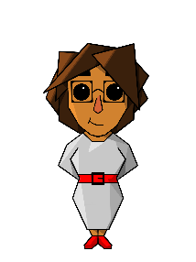 | “The Wallflower”: Quiet, interested in systems thinking and big ideas.  - Positive Attributes: Thoughtful, observes patterns others don’t see.  - Negative Attributes: Appears disengaged, not always willing to share ideas.
“The Cheerleader”: Enjoys learning for the sake of it with an infectious attitude.
- Positive Attributes: Motivates peers, force of positive energy.
- Negative Attributes: Selfless to a fault, can put others needs ahead of their own
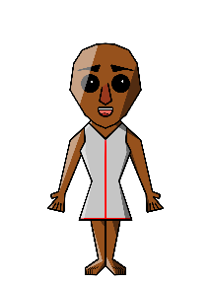 | “The Minimalist”: Efficient, seeks to understand concepts at a base level.  - Positive Attributes: Superior time management, functions well within structured environments.  - Negative Attributes: Impulsivity, struggles with big concepts and open-ended tasks.
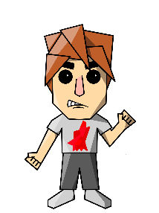 | “The Lone Wolf”: Highly self-motivated, confidence in their own abilities.  - Positive Attributes: Self-directed, autonomous worker.  - Negative Attributes: Difficulty collaborating, doesn’t always ask for help when needed.

Teaching Avatars
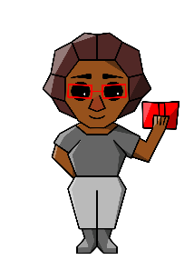 | "The Intellectual": The Intellectual shows people the value of expertise and excellence. Nobody knows more about the content than them, and they are proud of the long hours and work it took to become the top in their field. People with the same passion demand to be taught by The Intellectual and they will sacrifice much to sit at their feet.  - Positive Attributes: Content expert, a model for those aspiring to be the best  - Negative Attributes: Aloof and unable to connect to those who aren’t as motivated, unorganized (in a “crazy genius” way)  - What students or clients might say: "They know [subject matter] better than anyone else in the world. They have an answer for every question I ask."
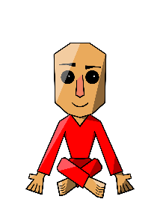 | "The Guru": The Guru (much like The Intellectual) is widely recognized as a leader or at the top of their profession. They often have such a large following that most of their teaching is done 1:many (asynchronously). The Guru functions as a celebrity in the life of the student and can often be a celebrity in the general public.  - Positive Attributes: Industry leader, a long track record of success with a proven method  - Negative Attributes: Does not connect well with people individually, tends toward a one-size-fits-all solution that scales  - What students or clients might say: "Their materials are world-class. They’ve accomplished so much with a proven method."
"The Innovator": The Innovator leads by example, taking their clients or students into exciting and uncharted territory. They are educated and risk tolerant, willing to take chances and show people the value of failure. The Innovator favors progress over tradition, and appeals to people who don't want to learn the traditional way simply because that's how it's always been done.
- Positive Attributes: Intelligent, risk taker, doesn't do things because they've always been done that way
- Negative Attributes: Focuses more on the content than the student, can become frustrated with non-risk takers
- What students or clients might say: "Never a dull moment in their sessions. Their clients love the fact that it's never the same thing twice."

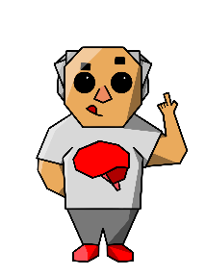 | "The Big Thinker": The Big Thinker has a rare or unique perspective that certain students crave. They make connections and open possibilities for people who might not yet see the opportunities for themselves. The Big Thinker has developed a system or methodology with clients who become more like disciples.  - Positive Attributes: Organized, universal system or methodological approach  - Negative Attributes: Puts most of accountability on client, leaving behind those who need more explicit directions  - What students or clients might say: "Their perspective is so unique. It really forces people to think in different and exciting ways."
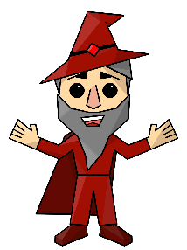 | "The Storyteller": The Storyteller is the "anti-teacher," the entertainer, the parable-maker. They can hold people’s attention for long periods of time, often telling stories with an ease and charisma that is mesmerizing. Because The Storyteller taps into the primitive nature of story and learning, people never forget what they’ve learned.  - Positive Attributes: Holds everyone's attention, easy to remember ideas presented  - Negative Attributes: Focuses more on their performance than client or student comprehension  - What students or clients might say: "People sit and listen to them for hours. It doesn't even feel like learning with them around."
"The Commander": The Commander leads by enforcing clear and concise structure. They have a system that they expect people to follow, and if they do so, they'll be almost guaranteed success. The Commander shows students or clients the value of consistency and accountability, as they learn how to learn.
- Positive Attributes: Keeps the trains running on time, highly organized and structured
- Negative Attributes: Lacks creativity, teaches to the middle (trying to please everyone)
- What students or clients might say: "Their expectations are always so clear. Everyone knows what to do and when."

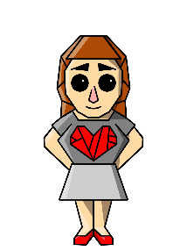 | "The Favorite": The Favorite attracts people who will do anything for them. They’re charismatic and magnetic, getting students or clients to care about concepts or ideas they previously rejected or dismissed. The Favorite stands up for their people, and much like The Coach, those people develop an intense loyalty to them and their approach.  - Positive Attributes: Relates to people, protects their group and advocates for them  - Negative Attributes: Lack of follow-up/accountability, students not part of their “inner circle” feel left out  - What students or clients might say: "People never really cared about [subject] until they met The Favorite. They can't wait for the next session."
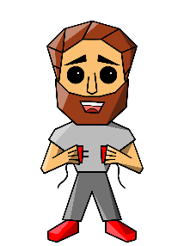 | "The Connector": The Connector understands people as individuals, and more importantly, what motivates them and how they connect with others. They read people quickly, delivering authentic and positive reinforcement by observing and remarking on a student or client's strengths. The Connector groups people in a way that utilizes their strengths, compensates for their weaknesses, and minimizes conflict between them.  - Positive Attributes: Develops personal relationships, knows how to connect people to get the most out of them  - Negative Attributes: Eternal optimism or positive energy can sometimes appear as manipulative or inauthentic  - What students or clients might say: "They really know how to get the most out people. They're so productive in cohorts or groups."
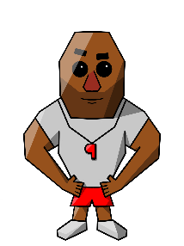 | "The Coach": The Coach sees their students as their team. Each member has a specific responsibility and must do their job, or the entire team “loses.” They drive students or clients hard, and they respond with absolute loyalty. The Coach thrives in competitive environments and is a master at training their students or clients through modeling.  - Positive Attributes: High expectations, loyal, highly motivating  - Negative Attributes: Demanding, intimidating, can alienate those skewing toward introversion  - What students or clients might say: "They’re tough on people, but students would run through a wall for them."
"The Manager": The Manager (much like The Connector) understands each person at their core. They believe (and demonstrate such) that everyone has a role to play in the learning environment, without using competition like The Coach. The Manager leaves "no soldier behind" and is 100% committed to the group's goals.
- Positive Attributes: Leverages the power of teamwork, finds a place for each person with no one left behind
- Negative Attributes: Not necessarily a subject matter expert, expressive approach can alienate those skewing toward introversion
- What students or clients might say: "They really understand each and every person. They recognize everyone's strengths and how they work together."

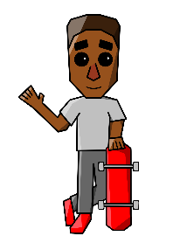 | "The Friend": The Friend (much like The Favorite), creates an intensely loyal following. They treat everyone in a warm and supportive way, even when people fall short of their expectations. The Friend becomes a role model for people in many facets of life.  - Positive Attributes: Warm and supportive of everyone, delivers individualized attention  - Negative Attributes: Expectations might be lower, doesn’t always hold people accountable  - What students or clients might say: "Everyone feels important and valued in their group. People ask them for advice on everything."

